# Influencer Management Agreement

This Influencer Management Agreement ("Agreement") is entered into on [Date] by and between:  
  
Manager: Arise Joseph  
  
Influencer: Hanachor iledachi vanessa  
  
Together, the "Parties" agree to the following terms and conditions:

## 1. Purpose of the Agreement

This Agreement outlines the responsibilities, expectations, and terms governing the professional relationship between the Manager and the Influencer. The goal is to collaboratively build and grow the Influencer's brand while ensuring effective management of business opportunities and content strategies.

## 2. Responsibilities of the Influencer

1. Content Approval:  
 - The Influencer must notify the Manager before posting any content on their social media platforms.  
2. Content Strategy:  
 - The Influencer agrees to follow the content ideas, themes, and schedules provided by the Manager to maintain consistency and audience engagement.  
3. Account Access:  
 - The Influencer will provide the Manager with necessary access to their social media accounts for monitoring analytics, planning content, and tracking performance.  
 - The Manager will not post or alter content without prior approval from the Influencer.  
4. Brand Deal Negotiations:  
 - All brand deals, sponsorships, and promotional opportunities must be negotiated and approved by the Manager.  
 - The Influencer agrees to direct all brand inquiries to the Manager for review and negotiation.  
5. Professional Conduct:  
 - The Influencer must maintain a professional online presence and avoid any actions that may damage their reputation or relationships with brands.  
6. Transparency:  
 - The Influencer must disclose any direct brand inquiries, offers, or communications to the Manager promptly.  
7. Exclusivity:  
 - The Influencer agrees to work exclusively with the Manager for all influencer-related activities during the term of this Agreement.  
8. Collaboration:  
 - The Influencer is encouraged to provide feedback and suggestions to the Manager to enhance strategies and improve overall performance.

## 3. Responsibilities of the Manager

1. Develop content strategies, and themes tailored to the Influencer's brand and audience.  
2. Handle all negotiations and communications with brands to secure the best opportunities.  
3. Monitor social media insights, track performance, and adjust strategies to optimize growth.  
4. Provide guidance on maintaining a professional and engaging online presence.  
5. Ensure compliance with legal and advertising standards for sponsored content.

## 4. Term and Termination

1. Term: This Agreement begins on 10/01/2025 and continues unless terminated earlier as per this section.  
2. Termination: Either party may terminate this Agreement with 30 days notice.

## 5. Confidentiality

Both Parties agree to keep all sensitive information, such as financial details, brand contracts, and strategies, confidential during and after the term of this Agreement.

## 8. Entire Agreement

This Agreement constitutes the full understanding between the Manager and the Influencer and supersedes any prior verbal or written agreements. Any modifications must be made in writing and signed by both Parties.

## Signatures

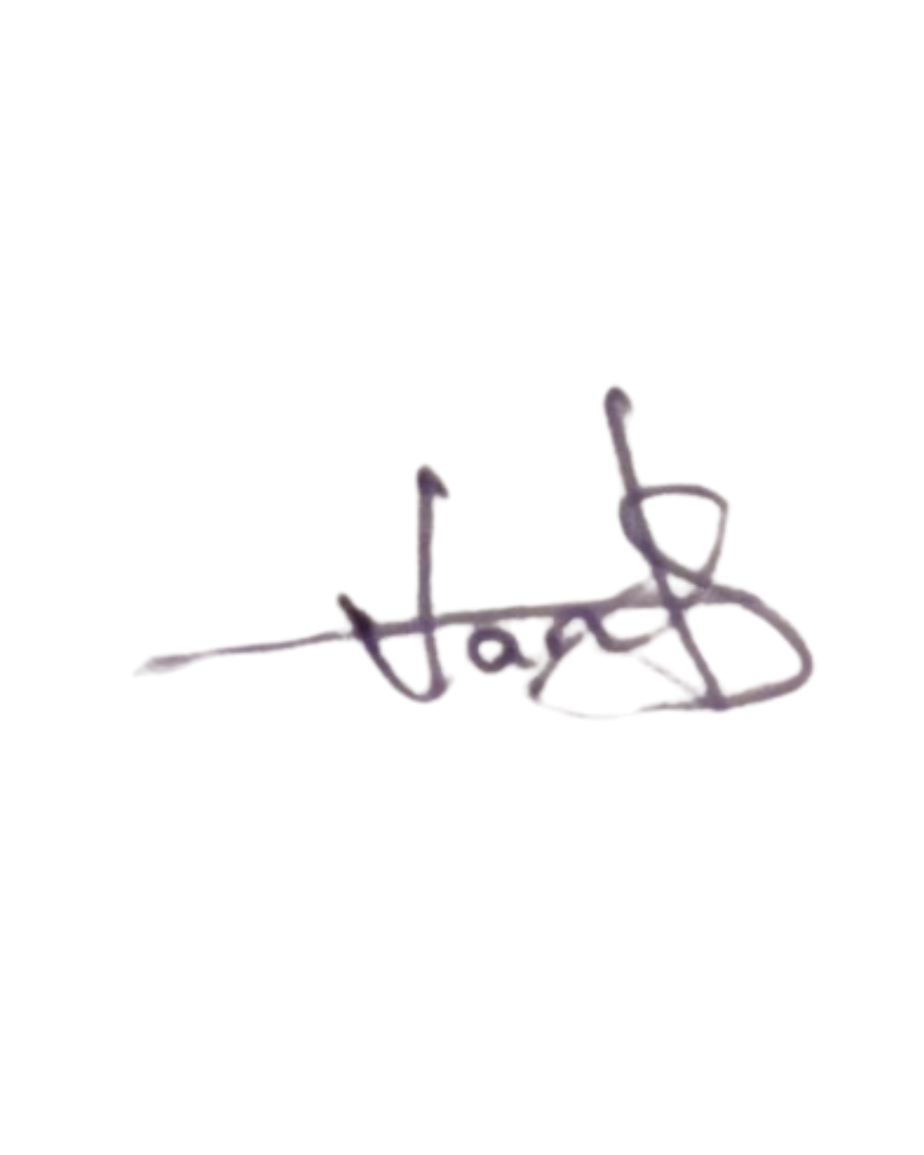Manager: ___________________________

Date: 10/01/2025

Influencer: __________________________

Date: 16/01/2025